**PRACTICAL 1**

**1. Install and configure PHP web server, MYSQL.**

**Step 1**

To download the XAMPP server, visit the "[Apache Friends](https://www.apachefriends.org/index.html)" website in your web browser.

**Step 2**

Click on "XAMPP for Windows". Then, navigate the downloading location and the file will be automatically downloaded.

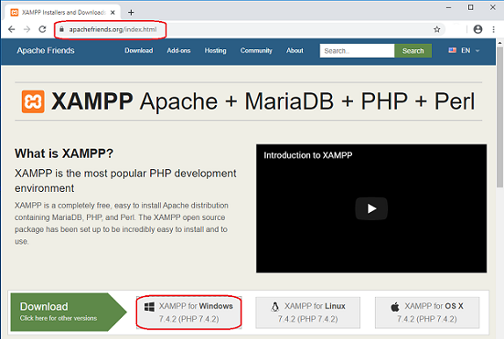

**Step 3**

Double-click the downloaded file to launch the XAMPP installer.

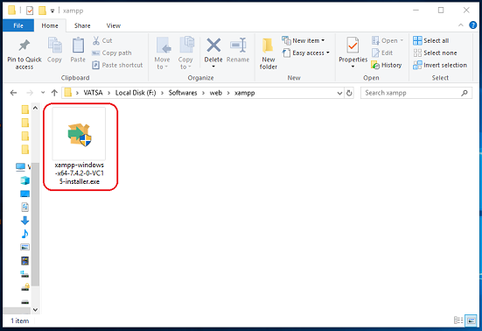

**Step 4**

"Setup" window will appear on the screen. Then, click on the "Next" button.

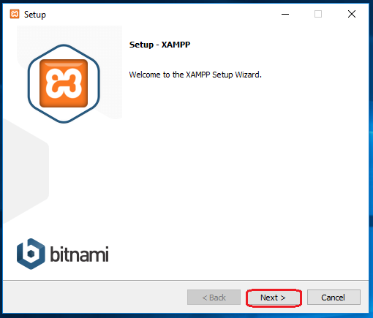

**Step 5**

Select the components that you want to install and click on the "Next" button.

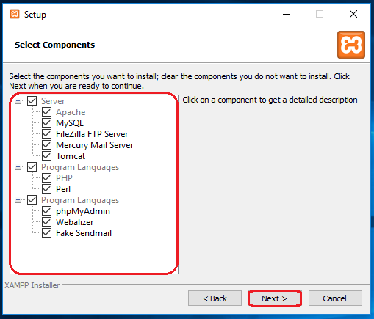

**Note**

By default, all components are selected in your XAMPP installation.

**Step 6**

Choose a folder to install the XAMPP and click on the "Next" button.

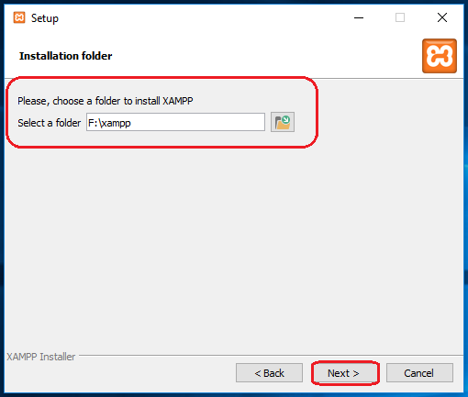

**Step 7**

Uncheck the "Learn more about Bitnami for XAMPP" option and click on the "Next" button.

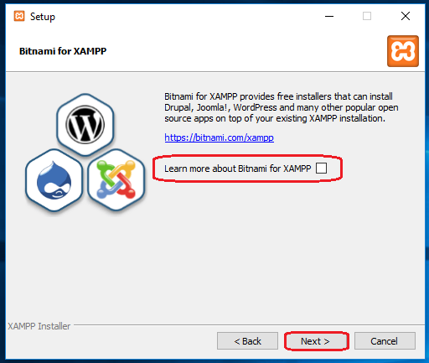

**Step 8**

"Ready to Install" window will appear on the screen, then click on the "Next" button.

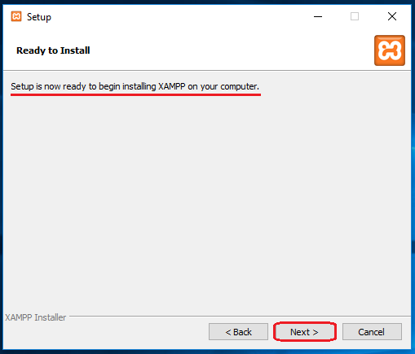

**Step 9**

Click on the "Finish" button.

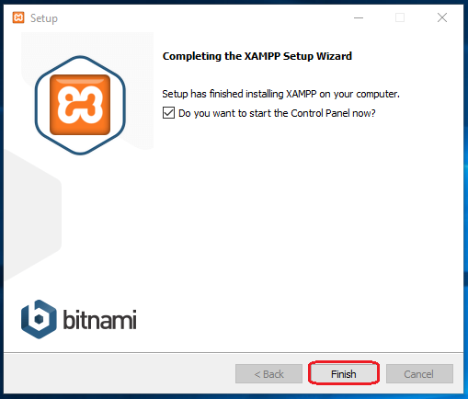

**Step 10**

Select a language. (either English or German) and click on the "Save" button.

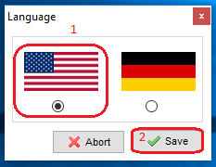

Configuration Process of XAMPP Server

**Step 1**

Start the XAMPP control panel through the "Run as administrator" option.

**Step 2**

"XAMPP Control Panel" will appear on the screen and click on "Start" action to start the "Apache" and "MySQL" modules.

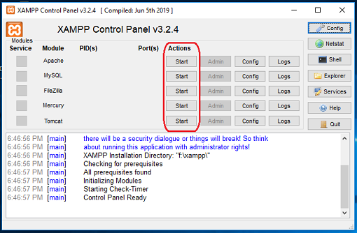

**Note:-**

The default XAMPP server settings should work for most users. When you start the related modules (services) then, the color of the related modules (service) becomes change into the green color and the PID(s) and the Port(s) number will also be shown to the user.

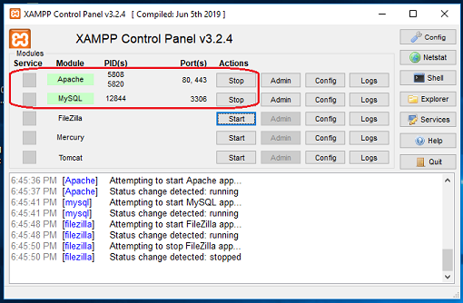

Fix an Issue of Apache not Starting in XAMPP

Some of the users may face an issue with Apache and MySQL module services not working in XAMPP. However, depending on the setup configuration or usage of your system, you may need to change the port number of the Apache and the MySQL. For example, because the "World Wide Web Services" under "Internet Information Services (IIS)" is also run on port 80 in your system, which is also the default port of apache in XAMPP. And,  the two servers (applications) can not use (run) the same port simultaneously. Follow the instructions below to fix the problem with Apache and MySQL services.

**Method 1. Change the default port of Apache**

**Step 1**

Open the XAMPP Control Panel.

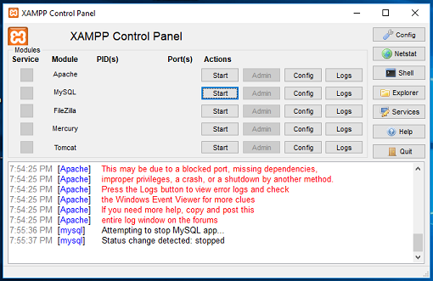

**Step 2**

In Apache Module Service, click on the "Config" button.

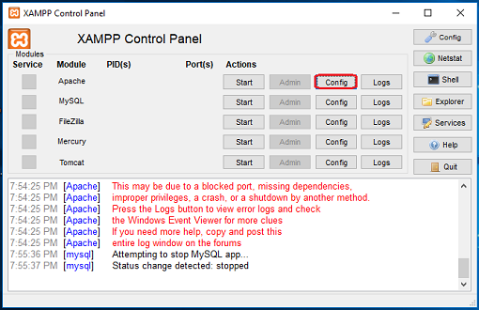

**Step 3**

Click on "Apache (httpd.conf)" option.

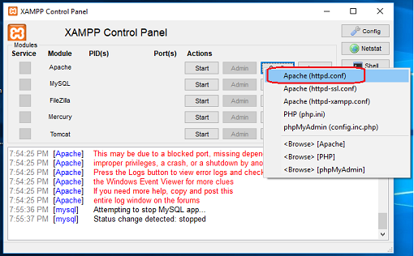

**Step 4**

By pressing the "Ctrl + F" key, find the "Listen 80" and replace it with another open port (like 81 or 9080) and save the file.

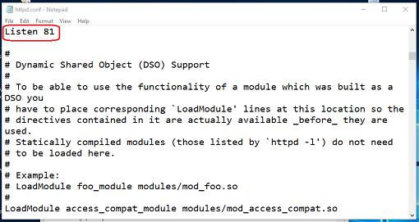

**Step 5**

Restart the XAMPP Server.

**Step 6**

Again, open the "XAMPP Control Panel" and click on the start option under the "Apache" module services.

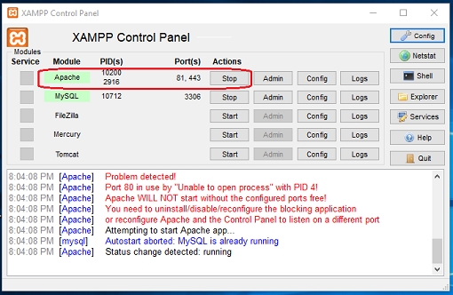

**Method 2. By disabling the Internet Information Services (IIS)**

**Step 1**

From the Start Menu, search for Control Panel.

**Step 2**

Click on "Programs".

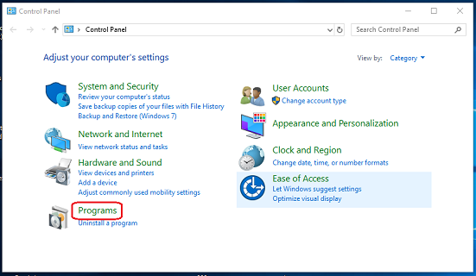

**Step 3**

Click on the "Turn Windows Feature on or off" option.

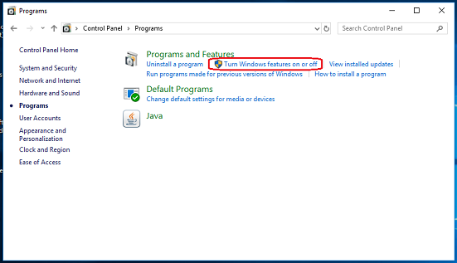

**Step 4**

Uncheck (clear) the "Internet Information Services" option and click on the "OK" button.

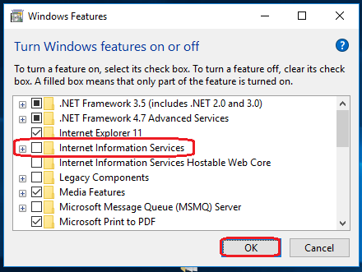

**Step 5**

Click on the "Restart Now" option (This will reboot/restart your computer/laptop).

**Step 6**

Again, open the "XAMPP Control Panel" and click on the start option in the "Apache" module services.

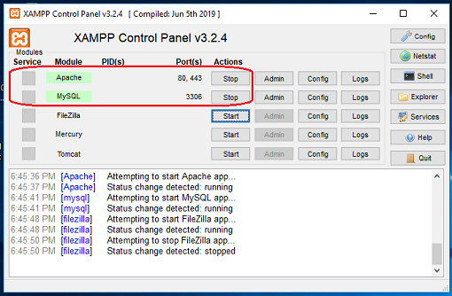

**2. Write a program to print “Welcome to PHP”.**

<?php

echo "Welcome to PHP";

?>

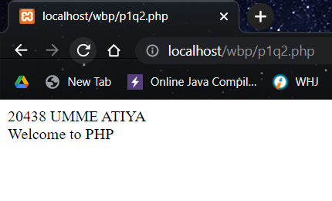

**3. Write a simple PHP program using expressions and operators**

**a. Write a Program to take three variables and perform Addition, Subtraction, Multiplication, Division and Modulus.**

<?php

echo "20438 UMME ATIYA <br>";

$n1=5;

$n2=2;

$add=$n1 + $n2;

$sub=$n1 - $n2;

$div=$n1 / $n2;

$mul=$n1 * $n2;

$mod=$n1 % $n2;

echo "<br>1st Number: ".$n1. "-------2nd Number: ".$n2;

echo "<br><br>Addition: ".$add;

echo "<br>Subtraction: ".$sub;

echo "<br>Multiplication: ".$mul;

echo "<br>Division: ".$div;

echo "<br>Modulus: ".$mod;

?>

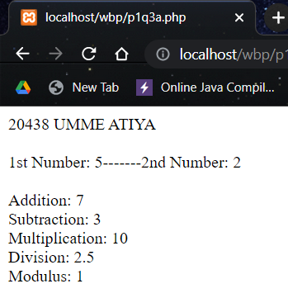

**4. Write a program to demonstrate the use of GLOBAL keyword in PHP.**

<?php

echo "20438 UMME ATIYA <br><hr>";

$name = "This is global variable"; //Global Variable

function global_var()

{

global $name;

echo "Variable inside the function: " . $name;

echo "</br>";

}

global_var();

echo "Variable outside the function: " . $name;

?>

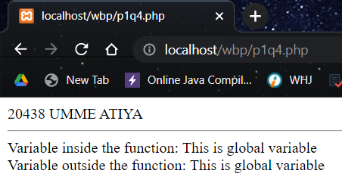

**5. Write a program to demonstrate the use of**

**GLOBAL array in PHP.**

<?php

echo "20438 UMME ATIYA <br><hr>";

$num1 = 5; //global variable

$num2 = 13; //global variable

function global_var()

{

$sum = $GLOBALS['num1'] + $GLOBALS['num2'];

echo "Sum of global variables is: " . $sum;

}

global_var();

?>

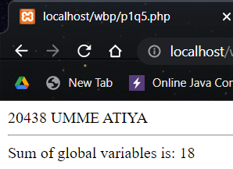

**6. Write a program to demonstrate the use of STATIC keyword in PHP.**

<?php

echo "20438 UMME ATIYA <br><hr>";

function static_var()

{

static $num1 = 3; //static variable

$num2 = 6; //Non-static variable

//increment in non-static variable

$num1++;

//increment in static variable

$num2++;

echo "Static: " . $num1 . "</br>";

echo "Non-static: " . $num2 . "</br>";

}

//first function call

static_var();

//second function call

static_var();

?>

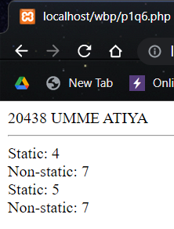

**PRACTICAL 2**

**1. Write a Program to print whether the number is Even or Odd using if else statement.**

<?php

echo "20438 UMME ATIYA <br>";

$num=5;

if($num%2==0){

echo "$num is even number";

}

else{

echo "$num is odd number";

}

?>

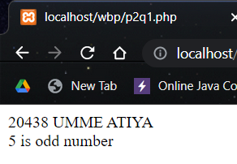

**2. Write a Program to print whether the character is Vowel or not using else if ladder.**

<?php

echo "20438 UMME ATIYA <br>";

$a = 'o';

if ($a == 'a') {

echo $a . " is a vowel";

} else if ($a == 'e') {

echo $a . " is a vowel";

} else if ($a == 'i') {

echo $a . " is a vowel";

} else if ($a == 'o') {

echo $a . " is a vowel";

} else if ($a == 'u') {

echo $a . " is a vowel";

} else {

echo $a . " is a component";

}

?>

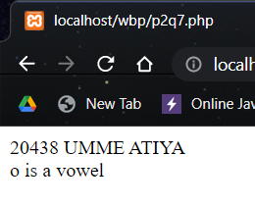

**3. Write a Program to print the**

**greatest of three numbers using**

**nested if else.**

<?php

echo "20438 UMME ATIYA <br>";

$n1 = 5;

$n2 = 2;

$n3 = 7;

if ($n1 > $n2 && $n1 > $n3) {

echo "$n1 is the greatest number";

} else {

if ($n2 > $n1 && $n2 > $n3) {

echo "$n2 is the greatest number";

} else {

echo "$n3 is the greatest number";

}

}

?>

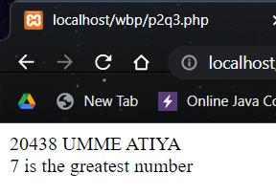

**4. Write a Program to print whether the year is the Leap Year or not using if else statement.**

<?php

echo "20438 UMME ATIYA <br>";

$n1 = 2004;

if ($n1 % 2 == 0) {

echo "Leap Year";

} else {

echo "Not a Leap Year";

}

?>

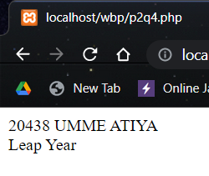

**5. Write a Program to print the Day of the Week using Switch Statement.**

<?php

echo "20438 UMME ATIYA <br>";

$s = 7;

switch ($s) {

case 1:

echo "Sunday";

break;

case 2:

echo "Monday";

break;

case 3:

echo "Tueday";

break;

case 4:

echo "Wednesday";

break;

case 5:

echo "Thursday";

break;

case 6:

echo "Friday";

break;

case 7:

echo "Saturday";

break;

default:

echo "Enter valid Number!";

break;

}

?>

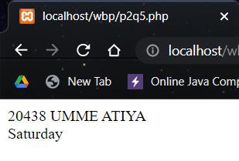

**6. Write a Program to print the Month of the Year using Switch Statement.**

<?php

echo "20438 UMME ATIYA <br>";

$m = 4;

switch ($m) {

case 1:

echo "January";

break;

case 2:

echo "Febrauary";

break;

case 3:

echo "March";

break;

case 4:

echo "April";

break;

case 5:

echo "May";

break;

case 6:

echo "June";

break;

case 7:

echo "July";

break;

case 8:

echo "August";

break;

case 9:

echo "September";

break;

case 10:

echo "October";

break;

case 11:

echo "November";

break;

case 12:

echo "December";

break;

}

return 0;

?>

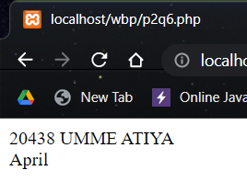

**7. WAP to print whether it is a Vowel or not using Switch Statement.**

<?php

echo "20438 UMME ATIYA <br>";

$s='a';

switch($s){

case 'a':

echo "vowel";

break;

case 'e':

echo "vowel";

break;

case 'i':

echo "vowel";

break;

case 'o':

echo "vowel";

break;

case 'u':

echo "vowel";

break;

default:

echo "consonant";

break;

}

?>

